

**CAPSTONE PROJECT 2**

**DATABASE DESIGN DOCUMENT**

***FACE CHECK-IN***

**Version:** 1.2

**Project Team:** BeeDev

**Date Create:** 18 – Apr – 2017

|  |  |  |  |  |  |
| --- | --- | --- | --- | --- | --- |
| **PROJECT INFORMATION** | | | | | |
| **Project Acronym** | FCI | | | | |
| **Project Title** | Face Check-in | | | | |
| **Start Date** | 10 – Feb – 2017 | | **End Date** | 10 – May – 2017 | |
| **Lead Institution** | International School, Duy Tan University | | | | |
| **Project Mentor** | MSc. Dieu B. HUYNH  Email: dieuhb@gmail.com  Phone: 0914146868  Mr. Luu D. VO  Email: [luke@enclave.vn](mailto:luke@enclave.vn)  Phone: 0983555494 | | | | |
| **Product Owner & Contact Detail** | Toai T. PHAN  Email: [se.thanhtoai@gmail.com](mailto:se.thanhtoai@gmail.com)  Phone: 0967764858 | | | | |
| **Partner Organization** | Enclave | | | | |
| **Project Manager &Scrum Master** | Toai T. PHAN | [se.thanhtoai@gmail.com](mailto:se.thanhtoai@gmail.com) | | | 0967764858 |
| **Team Members** | Chau T.M. PHAM | chauphamdn@gmail.com | | | 01666164333 |
| Nhan N. TRAN | [ngocnhan.nplus@gmail.com](mailto:ngocnhan.nplus@gmail.com) | | | 0947642354 |
| Giang T. NGUYEN | <ntgiang20494@gmail.com> | | | 0964755320 |
| Phung T.N. LE | <lethinhuphung95@gmail.com> | | | 0905145635 |

|  |  |  |  |
| --- | --- | --- | --- |
| **DOCUMENT NAME** | | | |
| **Document Title** | Database Design Document | | |
| **Author(s)** | Toai T. PHAN, Chau T.M. PHAM | | |
| **Role** | Scrum Master | | |
| **Date** | 18 – Apr – 2017 | **File name:** | [FCI] Database Design ver 1.1 |
| **URL** |  | | |
| **Access** |  | | |

|  |  |  |  |
| --- | --- | --- | --- |
| **REVISION HISTORY** | | | |
| **Version** | **Person(s)** | **Date** | **Description** |
| **1.0** | Toai T. PHAN | 06 – Mar – 2017 | Draft |
| **1.1** | Chau T.M. PHAM | 29 – Mar – 2017 | Edit |
| **1.2** | Toai T. PHAN | 18 – Apr – 2017 | Complete |

|  |  |  |  |
| --- | --- | --- | --- |
| **Document Approval**  The following signatures are required for approval of this document | | | |
| **Mentor** | MSc. Dieu B. HUYNH | **Signature:** |  |
| **Date:** |  |
| Mr. Luu D. VO | **Signature:** |  |
| **Date:** |  |
| **Scrum Master** | Toai T. PHAN | **Signature:** |  |
| **Date:** |  |
| **Team Member(s)** | Chau T.M. PHAM | **Signature:** |  |
| **Date:** |  |
| Nhan N. TRAN | **Signature:** |  |
| **Date:** |  |
| Giang T. NGUYEN | **Signature:** |  |
| **Date:** |  |
| Phung T.N. LE | **Signature:** |  |
| **Date:** |  |

Table of Contents

**1.** **Introduction** 6

**1.1.** **Purpose** 6

**1.2.** **Goal** 6

**1.3.** **Scope** 6

**1.4.** **Definitions, Acronyms and Abbreviations** 6

**2.** **Database Design** 7

**2.1.** **Table Overview** 7

**2.2.** **Entity Relationship Diagram** 8

**2.3.** **Table Relationship Diagram** 9

**2.4.** **Details** 10

**2.4.1.** **Account** 10

**2.4.2.** **Class** 10

**2.4.3.** **Course** 10

**2.4.4.** **Department** 10

**2.4.5.** **Faculty** 11

**2.4.6.** **Instructor** 11

**2.4.7.** **Role** 11

**2.4.8.** **Schedule** 11

**2.4.9.** **Student** 12

**2.4.10.** **STUDENT_COURSE** 12

**2.4.11.** **Tracking** 12

**2.4.12.** **UserData** 12

1. **Introduction**
   1. **Purpose**

Place information system’s database design document describes structure of database and file structure of system. Database Design document will introduce all attribute the system that will help developer and tester base on this design to implement and test.

* 1. **Goal**

To create database tables most accurate.

* 1. **Scope**
* This Database Design Document provides the basic for “Face Check-In” system Database design.
* It defines the database that will support the “Face Check-In” system Data Model.
* It describes both logical and physical definition, non-functional issues, and the database interfaces, storage aspects are defined in the physical database design sections.
* The table’s performance considerations requirements. The following topics are covered in this document:
* Assumptions and decisions on database design.
* Entity-mapping.
* Table column definitions.
* Primary, unique and foreign key definitions.
* Column and row level validation rules (check constraints).
* Rule for populating specific columns (sequences, derivations, demoralized (column)).
* Interfaces and dependencies with other components.
* Data access description.
* The database design for “Face Check-In” system is composed of definitions for database objects derived by mapping entities to tables attributes to columns, unique identifiers to unique keys and relationship to foreign keys.
* During design, these initial definitions are enhanced to support the functionality described in the functional specification/ user stories and defined in the primary and supporting modules of the application high level design.
  1. **Definitions, Acronyms and Abbreviations**

|  |  |  |
| --- | --- | --- |
| **Abbreviations** | **Description** | **Comment** |
| PK/FK | Primary/ Foreign Key | Use to indicate a file is a Primary or Foreign key in a table |
| ERD | Entity Relationship Diagram | Show the relationship between entities in the system |

1. **Database Design**
   1. **Table Overview**

***Table 1: Database Overview.***

|  |  |  |
| --- | --- | --- |
| **No** | **Table name** | **Short Description** |
| 1 | Account | This table shows all accounts of lecturer and admin |
| 2 | Class | This table shows all kind of class in school |
| 3 | Course | This table shows all information of course in the school. |
| 4 | Department | This table shows all information of department in the school. |
| 5 | Faculty | This table shows all information of faculty in the school. |
| 6 | Instructor | This table shows all information of instructor in the school. |
| 7 | Role | This table contains all role for each user |
| 8 | Schedule | This table shows all schedules. |
| 9 | Student | This table shows all information of student of school. This table show the relationship between kid and class |
| 10 | STUDENT_COURSE | This table show the relationship between student and course |
| 11 | Tracking | This table shows detail of time tracking of student |
| 12 | UserData | This table shows detail user data |

* 1. **Entity Relationship Diagram**

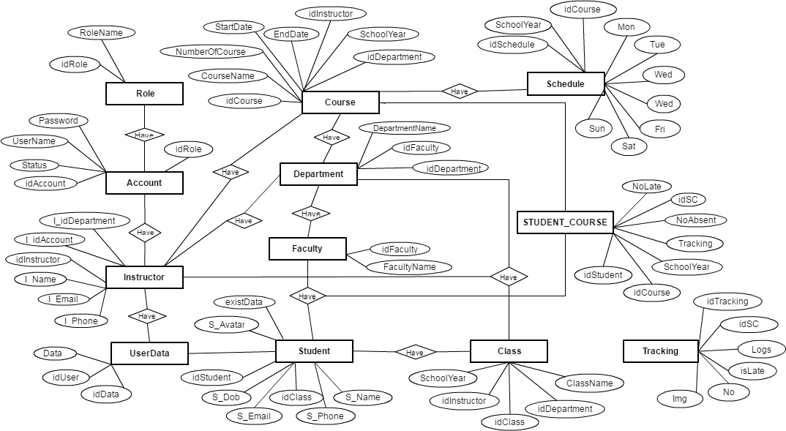

* 1. **Table Relationship Diagram**

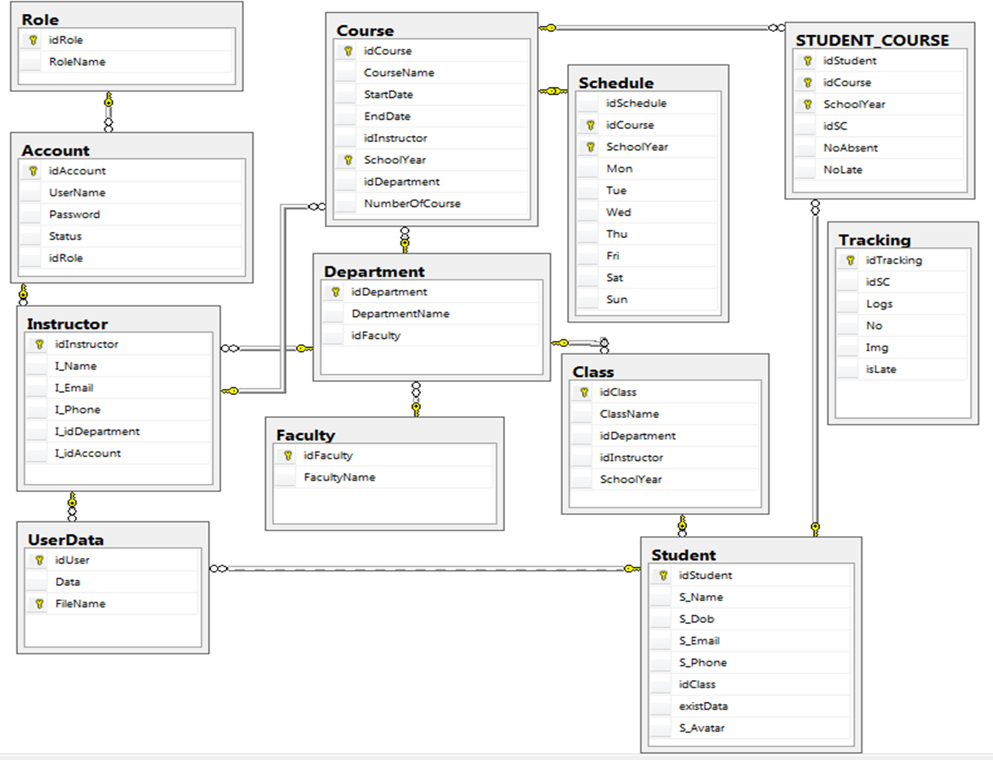

* 1. **Details**
     1. **Account**

**This includes the attributes: idAccount, UserName, Password, Status, idRole**

|  |  |  |  |  |  |
| --- | --- | --- | --- | --- | --- |
| **Attributes** | **Datatype** | **Null** | **Key** | **Default** | **Extra** |
| idAccount | int | not | PK |  |  |
| UserName | nvarchar(50) |  |  | NULL |  |
| Password | nvarchar(50) |  |  | NULL |  |
| Status | bit |  |  | NULL |  |
| idRole | int |  | FK |  |  |

* + 1. **Class**

**This includes the attributes: idClass, ClassName, idDepartment, SchoolYear, idInstructor.**

|  |  |  |  |  |  |
| --- | --- | --- | --- | --- | --- |
| **Attributes** | **Datatype** | **Null** | **Key** | **Default** | **Extra** |
| idClass | nvarchar(20) | not | PK |  |  |
| ClassName | nvarchar(50) |  |  | NULL |  |
| idDepartment | nvarchar(20) |  | FK |  |  |
| SchoolYear | nvarchar(10) |  |  | NULL |  |
| idInstructor | nvarchar(20) |  | FK |  |  |

* + 1. **Course**

**This includes the attributes: idCourse, CourseName, StartDate, EndDate, idInstructor, SchoolYear, idDepartment, NumberOfCourse**

|  |  |  |  |  |  |
| --- | --- | --- | --- | --- | --- |
| **Attributes** | **Datatype** | **Null** | **Key** | **Default** | **Extra** |
| idCourse | nvarchar(20) | not | PK, FK |  |  |
| CourseName | nvarchar(50) |  |  | NULL |  |
| StartDate | date |  |  | NULL |  |
| EndDate | date |  |  | NULL |  |
| idInstructor | nvarchar(20) |  | FK |  |  |
| SchoolYear | nvarchar(10) |  | PK, FK |  |  |
| idDepartment | nvarchar(20) |  | FK |  |  |
| NumberOfCourse | int |  |  | NULL |  |

* + 1. **Department**

**This includes the attributes: idDepartment, DepartmentName, idFaculty**

|  |  |  |  |  |  |
| --- | --- | --- | --- | --- | --- |
| **Attributes** | **Datatype** | **Null** | **Key** | **Default** | **Extra** |
| idDepartment | nvarchar(20) | not | PK |  |  |
| DepartmentName | nvarchar(50) |  |  | NULL |  |
| idFaculty | nvarchar(20) |  | FK |  |  |

* + 1. **Faculty**

**This includes the attributes: idFaculty, FacultyName.**

|  |  |  |  |  |  |
| --- | --- | --- | --- | --- | --- |
| **Attributes** | **Datatype** | **Null** | **Key** | **Default** | **Extra** |
| idFaculty | nvarchar(20) | not | PK |  |  |
| FacultyName | nvarchar(50) |  |  | NULL |  |

* + 1. **Instructor**

**This include the attributes: idInstructor, I_Name, I_Email, I_Phone, I_idDepartment, I_idAccount**

|  |  |  |  |  |  |
| --- | --- | --- | --- | --- | --- |
| **Attributes** | **Datatype** | **Null** | **Key** | **Default** | **Extra** |
| idInstructor | nvarchar(20) | not | PK |  |  |
| I_Name | nvarchar(50) |  |  | NULL |  |
| I_Email | nvarchar(50) |  |  | NULL |  |
| I_Phone | nvarchar(20) |  |  | NULL |  |
| I_idDepartment | nvarchar(20) |  | FK |  |  |
| I_idAccount | int |  | FK |  |  |

* + 1. **Role**

**This includes the attributes: idRole, RoleName.**

|  |  |  |  |  |  |
| --- | --- | --- | --- | --- | --- |
| **Attributes** | **Datatype** | **Null** | **Key** | **Default** | **Extra** |
| idRole | int | not | PK |  |  |
| RoleName | nvarchar(50) |  |  | NULL |  |

* + 1. **Schedule**

**This includes the attributes: idSchedule, idCourse, SchoolYear, Mon, Tue, Wed, Thu, Fri, Sat, Sun.**

|  |  |  |  |  |  |
| --- | --- | --- | --- | --- | --- |
| **Attributes** | **Datatype** | **Null** | **Key** | **Default** | **Extra** |
| idSchedule | int | not |  |  |  |
| idCourse | nvarchar(20) | not | PK |  |  |
| SchoolYear | nvarchar(10) | not | PK |  |  |
| Mon | nvarchar(50) |  |  |  |  |
| Tue | nvarchar(50) |  |  | NULL |  |
| Wed | nvarchar(50) |  |  | NULL |  |
| Thu | nvarchar(50) |  |  | NULL |  |
| Fri | nvarchar(50) |  |  | NULL |  |
| Sat | nvarchar(50) |  |  | NULL |  |
| Sun | nvarchar(50) |  |  | NULL |  |

* + 1. **Student**

**This includes the attributes: idStudent, S_Name, S_Dob, S_Email, S_Phone, idClass,ExistData, S_Avatar.**

|  |  |  |  |  |  |
| --- | --- | --- | --- | --- | --- |
| **Attributes** | **Datatype** | **Null** | **Key** | **Default** | **Extra** |
| idStudent | nvarchar(20) | not | PK |  |  |
| S_Name | nvarchar(50) |  |  | NULL |  |
| S_Dob | date |  |  | NULL |  |
| S_Email | nvarchar(50) |  |  | NULL |  |
| S_Phone | nvarchar(50) |  |  | NULL |  |
| idClass | nvarchar(20) |  | FK |  |  |
| ExitsData | bit |  |  | NULL |  |
| S_Avatar | image |  |  | NULL |  |

* + 1. **STUDENT_COURSE**

**This includes the attributes: idStudent, idCourse, SchoolYear, Tracking, idSC, NoAbsent, NoLate.**

|  |  |  |  |  |  |
| --- | --- | --- | --- | --- | --- |
| **Attributes** | **Datatype** | **Null** | **Key** | **Default** | **Extra** |
| idStudent | nvarchar(20) | not | FK |  |  |
| idCourse | nvarchar(20) | not | FK |  |  |
| SchoolYear | nvarchar(20) | not | FK |  |  |
| idSC | int |  |  | NULL |  |
| NoAbsent | int |  |  | NULL |  |
| NoLate | int |  |  | NULL |  |

* + 1. **Tracking**

**This includes the attributes:idSC, idTracking, Logs, No, Image, IsLate**

|  |  |  |  |  |  |
| --- | --- | --- | --- | --- | --- |
| **Attributes** | **Datatype** | **Null** | **Key** | **Default** | **Extra** |
| idTracking | int | not | PK |  |  |
| idSC | int |  |  |  |  |
| Logs | nvarchar(MAX) |  |  |  |  |
| No | int |  |  |  |  |
| Image | image |  |  |  |  |
| IsLate | nvarchar(50) |  |  |  |  |

* + 1. **UserData**

**This includes the attributes: idData, idUser, Data**

|  |  |  |  |  |  |
| --- | --- | --- | --- | --- | --- |
| **Attributes** | **Datatype** | **Null** | **Key** | **Default** | **Extra** |
| idData | int | not | PK |  |  |
| idUser | nvarchar(20) |  | FK |  |  |
| Data | image |  |  | NULL |  |